§ 270-7. Yard requirements.
- Front yards. In determining the minimum front yard setbacks for lots, the front yard is the area generally located between the street and the principal structure, regardless of the orientation of the structure or the location of the driveway(s).
- Front yards for corner lots. On lots located on a street corner with an angle no larger than 120°, the minimum front yard setback must be met for the yard along both streets. For corner lots where the angle of the street intersection is greater than 120°, the front yard shall be considered the area between the front of the building and the street that most closely parallels the front of the building.
- Side and rear yards for corner lots. On corner lots in which it has been determined that two front yards exist, the rear yard shall be the area between the rear of the house or structure and the lot line most parallel to the rear of the house or structure. In determining what constitutes the rear of the house or structure, it is the side of the house or structure opposite the front door or main entrance. The remaining yard becomes the side yard by default.
- Yard requirements for attached accessory structures. All accessory structures that are attached to the principal building (i.e., attached garages, attached covered patios, etc.) shall comply with the yard setback requirements of the principal building.
- Yard requirements for buildings not parallel to lot lines. Often residences and buildings are not oriented so that they are parallel to the front, rear, or side lot lines. Regardless of the building orientation, all points on the wall of a building must meet the applicable minimum front, rear, and side yard setback requirements.
- Extension of building line where setbacks are presently substandard. In those instances where a building does not meet one or more of the minimum yard setback requirements, the building may be extended or added to without the need for an area variance, provided the building extension or addition does not decrease the already substandard yard setback.
- Use of yards. Every part of a required yard setback must be free of permanent buildings and structures, except for the maximum allowed projections of the following:

- Open fire escapes: six feet into the side or rear yard setback only; not allowed in front yards.
- Awnings and movable canopies: six feet.
- Cornices or eaves: three feet.
- Uncovered steps and porches (not including decks): six feet.
- Ornamental features or facade projections: six feet.
- Flags and banners mounted on the structure: eight feet.
- Prohibited uses within yards. Unless otherwise permitted in this chapter, yards are not to be used for the storage of merchandise, equipment, building materials, junk, garbage, unregistered vehicles, vehicle parts, signs, unused fencing, etc.
- Screening of dumpsters and utilities. Dumpsters, ground-level exterior heating and air-conditioning units, and similar items and utilities used for commercial or industrial uses shall be screened from public rights-of-way and from residentially zoned or residentially developed properties via vegetation and/or solid fencing.
- Trucks within residential districts. Excluding one ton pick-up passenger trucks , trucks with a carrying capacity of one ton or more may not be parked overnight on any residentially zoned property, except for trucks which are used as part of an agricultural operation or trucks used for the maintenance or upkeep of multifamily residential properties. In these instances, such trucks must either be parked within a barn, garage or similar structure, or if parked outside, located no closer than 75 feet to any dwelling or property line.
- RVs, campers, boats, etc. within residential districts. RVs, campers, popup campers, boats, snowmobiles, all-terrain vehicles, and similar vehicles, as well as trailers for hauling such vehicles, are not permitted within any residential front yard, unless enclosed within a garage, boathouse, or other structure that is in compliance with this chapter. Also, any such vehicles located in side or rear yards are to be parked on an existing driveway, or on an apron of concrete, brick, block, asphalt, crushed stone, or any other finished surface that prevents the growth of grass or weeds.
- Transitional yard requirements adjacent to industrial and warehousing uses. Where the side or rear lot line of a property in which an industrial or warehousing use is proposed abuts a

§ 270-7 § 270-7

property that is either already developed for nonindustrial or nonwarehousing purposes, or is zoned for something other than industrial or warehousing use, a minimum fifty-foot-wide buffer is to be maintained between the developed portion of the industrial or warehousing site and the abutting side or rear property line. This buffer is to remain free of buildings, structures, parking, roadways, dumpsters, etc. Further, the Planning and Zoning Commission and/or Zoning Board of Appeals may require landscaping, fencing, berming, and other forms of screening within this buffer area.
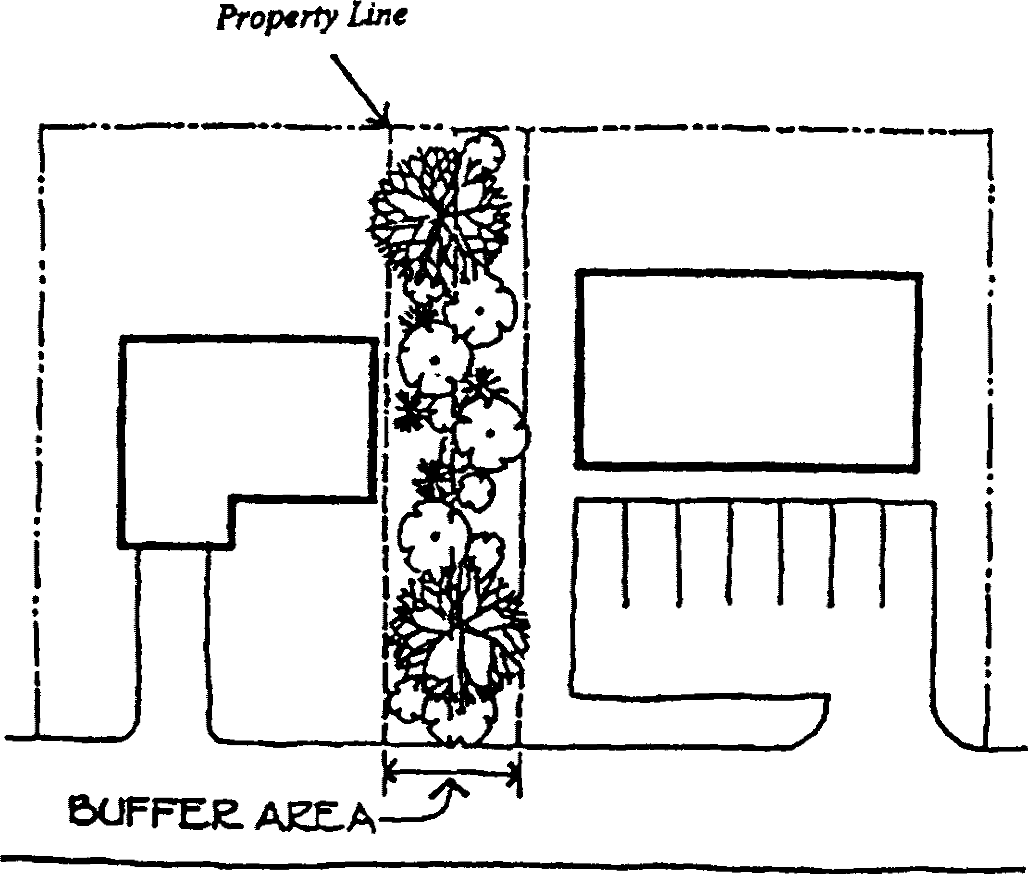

- Transitional yard requirements adjacent to commercial uses. Where the side or rear lot line of a property in which a commercial use is proposed abuts a property that is either already used for residential or park use, or is zoned for residential or park use, a minimum thirty-foot-wide buffer is to be maintained between the developed portion of the commercial site and the abutting side or rear property line. This buffer is to remain free of buildings, structures, parking, roadways, dumpsters, etc. Further,

the Planning and Zoning Commission and/or the Zoning Board of Appeals may require landscaping, fencing, berming, and other forms of screening within this buffer area.
- Setbacks on properties with buildings in excess of 20,000 square feet of gross floor area. When a structure in excess of 20,000 square feet of gross floor area is proposed on a lot adjacent to property zoned Suburban Residential, Rural Residential and Agricultural or Multi-Family, a side and rear yard building setback of 100 feet or greater must be provided.

